**Exp no. 4 UDP ECHO CLIENT SERVER COMMUNICATION**

**AIM:**

To implement an Echo Server and Client in Java using UDP sockets.

**ALGORITHM:**

**Server**

1. Create two ports, server port and client port.
2. Create a datagram socket and bind it to the client port.
3. Create a datagram packet to receive client messages.
4. Wait for the client's data and accept it.
5. Read Client's message.
6. Get data from users.
7. Create a datagram packet and send a message through the server port.
8. Repeat steps 3-7 until the client has something to send.
9. Close the server socket.
10. Stop.

**Client**

1. Create two ports, server port and client port.
2. Create a datagram socket and bind it to the server port.
3. Get data from users.
4. Create a datagram packet and send data with server ip address and client port.
5. Create a datagram packet to receive server messages.
6. Read the server's response and display it.
7. Repeat steps 3-6 until there is some text to send.
8. Close the client socket.
9. Stop.

**Server Program(ECHO):**

import java.net.*;

import java.io.*;

public class EServer

{

public static void main(String args[])

{

try

{

ServerSocket s= new ServerSocket(9000);;

String line;

Socket c=s.accept();

DataInputStream is=new DataInputStream(c.getInputStream());

PrintStream ps=new PrintStream(c.getOutputStream());

while(true)

{

line=is.readLine();

ps.println(line);

}

}

catch(IOException e)

{

System.out.println(e);

}

}

}

**Client Program (ECHO):**

import java.net.*;

import java.io.*;

public class EClient

{

public static void main(String arg[])

{

try

{

InetAddress ia = InetAddress.getLocalHost();

Socket c=new Socket(ia,9000);

String line;

PrintStream os=new PrintStream(c.getOutputStream());

DataInputStream is=new DataInputStream(System.in);

DataInputStream is1=new DataInputStream(c.getInputStream());

while(true)

{

System.out.println("Client:");

line=is.readLine();

os.println(line);

System.out.println("Server:" + is1.readLine());

}

}

catch(IOException e)

{

System.out.println("Socket Closed!");

}

}

}

**OUTPUT:**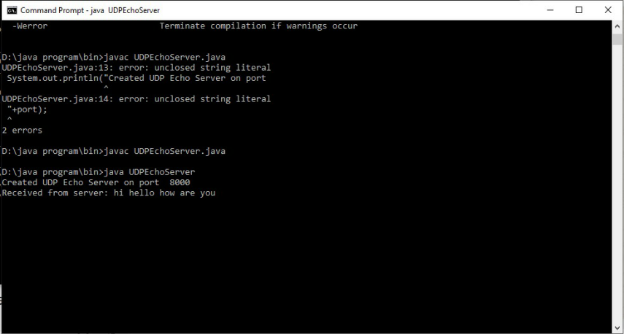

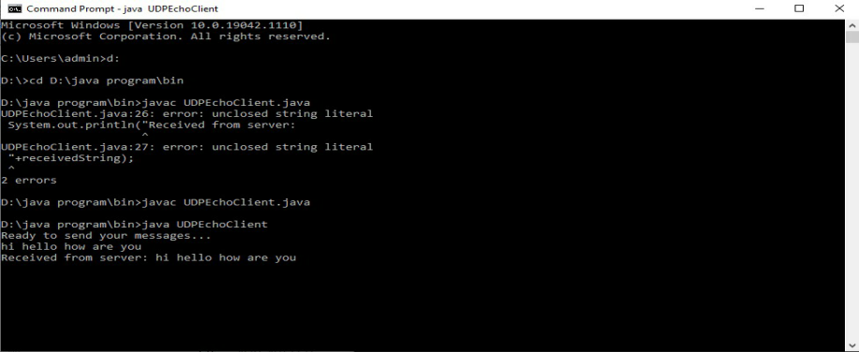

**RESULT:**

Thus UDP Echo Client Server Communication has been implemented.